
SAFEGUARDING POLICY (REPUBLIC OF IRELAND)

Introduction

Oxfam acknowledges that all children, young people and adults are entitled to live a life free from abuse and exploitation and our safeguarding policy is underpinned and guided by a number of guiding principles.

All children, young people and adults who come into contact with our services will be treated with dignity and respect and in a way that promotes equality and diversity.

Legislation and Guidance

With respect to safeguarding children and young people, Oxfam Ireland recognise (although not limited to in particular) the following legislation and guidance:

- Child Care Act 1991

- Protections for Persons Reporting Child Abuse Act 1998

- Criminal Justice Act 2006

- Criminal Justice (Withholding of Information on Offences against Children and Vulnerable Persons) Act 2012

- National Vetting Bureau (Children and Vulnerable Persons) Acts 2012–2016

- Children First Act 2015

- Criminal Law (Sexual Offences) Act 2017

- National Guidance for the Protection and Welfare of Children,

- Tusla’s Child Safeguarding: A Guide for Policy, Procedure and Practice,

- The United Nations Convention on the Rights of the Child

Definition of Terms

Child Safeguarding – ensuring safe practice and appropriate responses by staff and volunteers to concerns about the safety or welfare of children, should these arise. Child safeguarding is about protecting the child from harm, promoting their welfare and in doing so creating an environment which enables children and young people to grow, develop and achieve their full potential.

Child Safeguarding Statement – defined in the Children First Act 2015, this is a statement which includes a written assessment of risk of harm to children and the measures that will be taken to manage any identified risks.

Child Safeguarding Concern - The Child Protection and Welfare Practice Handbook defines a child welfare concern as “a problem experienced directly by a child, or the family of a child, that is seen to impact negatively on the child’s health, development and welfare, and that warrants assessment and support, but may not require a child protection response”.

1

Guiding principles and child safeguarding procedures – previously referred to as child protection and welfare policy and procedures, the procedures an organisation has in place to safeguard children from harm and reduce the risks to children of being harmed.

Child or young person - a person under the age of 18 years as defined by The United Nations Convention of the Rights of the Child.

Vulnerable Person- according to The Garda Vetting Bureau (children and vulnerable persons) Act 2012 means a person, other than a child, who:

- is suffering from a disorder of the mind, whether as a result of mental illness or dementia,

  - has an intellectual disability,

- is suffering from a physical impairment, whether as a result of injury, illness or age, or

- has a physical disability,

which is of such a nature or degree:

(i) as to restrict the capacity of the person to guard himself or herself against harm by another person, or

(ii) that results in the person requiring assistance with the activities of daily living including dressing, eating, walking, washing and bathing.

Child Protection and Welfare Report Form –form for use in reporting suspected or alleged abuse or welfare concerns to Tusla (available at www.tusla.ie) and Appendix 3.

Children First: National Guidance for the Protection and Welfare of Children – national, overarching guidance for the protection and welfare of children, published by the Department of Children and Youth Affairs. The current version was published in 2017.

Designated Liaison Person (DLP) or Deputy Designated Liaison Person (DDLP) – a resource to any staff member who has a child protection concern. Designated Liaison Person or Deputy Designated Liaison Persons are responsible for ensuring that reporting procedures are followed correctly and promptly and act as a liaison person with other agencies (see Children First: National Guidance).

Named person – a person appointed by an organisation to lead the development of guiding principles and child safeguarding procedures and for ensuring that policies and procedures are consistent with best practice.

Organisation – any department / sector / body / agency / organisation whether private, public or voluntary.

Relevant service – as defined in the Children First Act 2015, “means any work or activity specified in Schedule 1 [of that Act]” Full reference list included in Appendix 1.

Provider – as defined in the Children First Act 2015, “means, in relation to a relevant service, a person:

- who provides a relevant service, and

- who, in respect of the provision of such relevant service:

2

- employs (whether under contract of employment or otherwise) one or more than one other person to undertake any work or activity that constitutes a relevant service

- enters into a contract for services with one or more than one other person for the provision by the person of a relevant service or

  - permits one or more than one other person (whether or not for commercial or other consideration and whether or not as part of a course of education or training, including an internship scheme) to undertake any work or activity, on behalf of the person, that constitutes a relevant service”.

Relevant person – as defined in the Children First Act 2015, “means a person who is appointed by a provider of a relevant service to be the first point of contact in respect of the provider’s Child Safeguarding Statement”.

Mandated person – as defined in the Children First Act 2015, mandated persons have a statutory obligation to report concerns which meet or exceed a particular threshold to Tusla and to cooperate with Tusla in the assessment of mandated reports, where requested to do so (as listed in Appendix 2).

Tusla – Tusla is Ireland’s Child and Family Agency, the lead, statutory organisation for safeguarding children in Ireland.

Tusla Child Protection and Welfare Report Form – form for use in reporting to Tusla suspected or alleged abuse or welfare concerns in relation to children (see Appendix 3).

Retrospective Abuse Report Form (RARF) – form for use in reporting to Tusla suspected or alleged retrospective abuse or welfare concerns, on adults who allege childhood abuse (see appendix 4).

Declaration of Guiding Principles for Safeguarding Children

Oxfam Ireland comes in to contact with children, young people, and vulnerable adults through its work (shops, offices, campaign activities and events)

Oxfam Ireland may also involve young people from the age of 16 years in the organisation as a paid member of staff or as a volunteer. All roles are defined by role descriptions prior to commencement with the organisation; volunteer roles requiring completion of a written parental consent form also.

Oxfam Ireland believes in reference to children and young people:

- The safety and welfare of children and young people is everyone’s responsibility.

- The best interests of the child or young person should be paramount

- The voice of the child or young person should be heard, listened to and taken seriously, taking into account the age and understanding of the child / young person. Children and young people should be consulted and involved in all matters and decisions, which may affect their lives and be provided with appropriate support to do so where that is required.

3

- Equality – all children and young people have an equal right to attend and participate in an organisation that respects them as individuals and encourages them to reach their potential, regardless of their background.

- Prevention – the importance of preventing problems occurring or worsening through the introduction of timely supportive measures.

- Protection – we are committed to upholding the rights of every child and young person that is involved or comes in to contact with our organisation. Children should be safe from harm and in circumstances where their needs are not being met they must be protected.

- Shared responsibility - our guiding principles apply to all paid staff, volunteers, Council of Trustees and individuals on work placement within our organisation. Oxfam Ireland Council of Trustees, staff, volunteers and students must sign up to and abide by these guiding principles and our child safeguarding procedures.

Declaration of Guiding Principles for Adults

With respect to safeguarding adults, Oxfam recognises the following principles, to achieve best practice in this area:

- A Rights-Based Approach: to promote and respect an adult’s right to dignity; participation in society; be safe and secure; to freedom from harm and coercion; to equality of treatment; to the protection of the law; to privacy; to confidentiality; and freedom from discrimination.

- An Empowering Approach: to empower adults to make informed choices about their lives, to maximise their opportunities to participate in wider society, to keep themselves safe and free from harm and enabled to manage their own decisions in respect of exposure to risk.

- A Person-Centred Approach: to promote and facilitate full participation of adults in all decisions affecting their lives taking full account of their views, wishes and feelings and, where appropriate, the views of others who have an interest in their safety and well-being.

- Advocacy supported approach: to enable to know their rights and voice their concerns. To ensure individuals have access to all the relevant and accurate information to allow them to make informed choices.

- A Confidential assurance approach: to ensure all adults are secure in the knowledge that information held about them is managed appropriately and there is a clear understanding of confidentiality amongst staff and volunteers.

- A Consent-Driven Approach: to make a presumption that the adult has the ability to give or withhold consent; to make informed choices; to help inform choice through the provision of information, and the identification of options and alternatives; to have particular regard to the needs of individuals who require support with communication, advocacy or who lack the capacity to consent; and intervening in the life of an adult against his or her wishes only in particular circumstances, for very specific purposes and always in accordance with the law.

4

- A Collaborative Approach: to acknowledge that adult safeguarding will be most effective when it has the full support of the wider public and of safeguarding partners across the statutory, voluntary, community, independent and faith sectors working together and is delivered in a way where roles, responsibilities and lines of accountability are clearly defined and understood. Working in partnership and a person-centred approach will work hand-in-hand.

Oxfam Safeguarding Policy Statement

Oxfam will ensure that all children, young people and vulnerable adults, while engaging in our activities or services are in a safe, caring environment where they feel listened to and valued. This includes, but is not limited to, young people and vulnerable adults engaged in staff and volunteering activities with Oxfam.

Staff and volunteers in our organisation are committed to practice which promotes the welfare of children, young people and vulnerable adults and protects them from harm and exploitation.

Staff and volunteers accept and recognise our responsibilities to develop awareness of the issues that cause children, young people and vulnerable adults, harm, and to establish and maintain a safe environment for all. We will not tolerate any form of abuse or harmful treatment.

We are committed to promoting an atmosphere of inclusion, transparency and openness and are open to feedback from the people who use our services, parents, carers, advocates and our staff and volunteers, with a view to how we may continuously improve our services / activities.

Oxfam’s safeguarding policy is intended to cover all functions of Oxfam where staff and volunteers have contact with children, young people and vulnerable adults in the course of their duties.

This policy will be owned at all levels within Oxfam. Our Council of Trustees will direct the development of this policy and be responsible for its approval. All staff and volunteers within our organisation have a responsibility for the implementation of this policy. Everyone involved with our organisation including Oxfam Council of Trustees, Senior Management Team, staff, and volunteers will be provided with a copy of this policy statement. The policy statement and guiding principles will be prominently displayed in all Oxfam sites.

Staff and volunteers in Oxfam will endeavour to safeguard children, young people and vulnerable adults by:

- Adhering to our safeguarding policy and ensuring that it is supported by robust procedures

- Carefully following the procedures laid down for the recruitment and selection of staff and volunteers

- Providing effective management for staff and volunteers through support, supervision and training

- Implementing clear procedures for reporting concerns to statutory agencies that need to know, while involving children, vulnerable adults, parents, carers and advocates appropriately

- Implementing a code of behaviour for staff and volunteers

5

- Appropriately managing personal information, confidentiality and information sharing;

- Implementing clear procedures for receiving comments and suggestions and for dealing with concerns and complaints about our organisation and

- Ensuring general safety and risk management procedures are adhered to.

Oxfam’s safeguarding policy will be supported by organisational policies and procedures aimed at promoting safe and healthy work practices, including: recruitment and selection, learning and development, grievance and disciplinary / resolving differences, code of conduct, equal opportunities, health and safety, support and supervision, and volunteer policy.

Oxfam is committed to reviewing this policy every two years. The next review will take place in February 2020, unless there is a significant change to legislation, policy or practice in the interim.

6

Key child and vulnerable adult safeguarding roles in Oxfam Ireland (ROI)

Named Person - a person appointed by an organisation to lead the development of guiding principles and child and vulnerable adult safeguarding procedures and for ensuring that policies and procedures are consistent with best practice as detailed in the Tusla Child Safeguarding: A guiding for policy, Procedure and Practice.

Oxfam Ireland Named Person

Julie McSorley (Head of Human Resources)

Phone: +44 2890 895 955

Mobile: +44 7803 186 288

Designated Liaison Person (DLP) and Deputy Designated Liaison Person (DDLP) – The role of the DLP is to receive child protection and welfare concerns from workers / volunteers and to report concerns which meet the threshold of “reasonable grounds for concern” to Tusla. This is a resource to any staff member or volunteer who has a child protection concern. Designated Liaison Person or Deputy Designated Liaison Persons are responsible for ensuring that reporting procedures are followed correctly and promptly and act as a liaison person with other agencies.

Designated Liaison Person (DLP) | Deputy Designated Liaison Person (DDLP)
Julie McSorley (Head of Human Resources) | Elizabeth Martin (Volunteer Coordinator)
Phone: +44 2890 895 955 | Phone: +4428 9089 5960
Mobile: +44 7803 186 288 | Mobile: +44 7801 150160

Roles and responsibilities of the Designated Liaison Person (DPL) / Deputy DPL:

- Be fully familiar with your organisation’s duties in relation to the safeguarding of children and vulnerable adults.

- Have good knowledge of your organisation’s guiding principles and child and vulnerable adult safeguarding procedures.

- Ensure that the organisation’s reporting procedure is followed, so that child protection and welfare concerns are referred promptly to Tusla, and vulnerable adult concerns are reported to An Garda Síochána.

- Receive child and vulnerable adult protection and welfare concerns from workers and volunteers and consider if reasonable grounds for reporting to Tusla and/or An Garda Síochána exist.
- Consult informally with a Tusla Duty Social Worker on child protection concerns if necessary.

- Where appropriate, make a formal report of a child protection or welfare concern to Tusla on behalf of their organisation, using the Child Protection and Welfare Report Form; or report concerns about the safety or welfare of a vulnerable adult to An Garda Síochána.

- Inform the child’s parents / guardians that a report is to be submitted to Tusla or An Garda Síochána, unless:

7

  - Informing the parents / guardians is likely to endanger the child or young person

  - Informing the parents / guardians may place you as the reporter at risk of harm from the family

  - The family’s knowledge of the report could impair Tusla’s ability to carry out an assessment.

- Record all concerns or allegations of child or vulnerable adult abuse brought to your attention as well as any action / inaction taken in response to these concerns.

- Provide feedback to the referrer, as appropriate.

- Ensure that a secure system is in place to manage confidential records.

- Act as a liaison with Tusla and An Garda Síochána, as appropriate.

- Where requested, jointly report with a mandated person.

Safe Recruitment and Selection of Staff and Volunteers

Oxfam understands the importance of having good recruitment and selection procedures in place to minimise the opportunity for unsuitable people to work or volunteer with children, young people and vulnerable adults. Oxfam consistently applies a thorough and clearly defined method of recruiting staff and volunteers in line with legislative requirements and best practice.

Oxfam’s recruitment and selection procedures are fully outlined in both our Staff and Volunteer Recruitment and Selection Policies. Policies for both staff and volunteers include the following:

- Defining the post through clear job descriptions and personnel specifications for staff and clear role descriptions and volunteer specifications for volunteers. These identify the key skills, qualities, abilities and qualifications required to fill the post. The job / role description indicates whether the post involves the provision of relevant services as defined in schedule 1 of the children’s first act 2015 (see appendix 1).

- An open recruitment process.

- Completion of an application form / registration form, which will cover past work / volunteering experience.

- Completion of a declaration and consent form. The applicant must declare any “unspent” criminal convictions or prosecutions pending. In accordance with the Criminal Justice (Spent Convictions and Certain Disclosures) Act 2016 a range of minor offences will become spent after 7 years. This means that an adult convicted of an offence covered by the Act does not have to disclose the conviction after 7 years, except in certain circumstances. The convictions which may be regarded as spent after 7 years are set out in Section 5 of the Act The applicant must provide information on any investigation that has been carried out in relation to a child, young person or vulnerable adult abuse in which they have been the alleged perpetrator.

- Provision of consent to Garda vetting if they are considered the preferred candidate for a post involving a relevant service and have been conditionally offered the job / role subject to the results of appropriate checks.

- Oxfam Ireland will request two written references and interview with at least two Oxfam representatives when recruiting staff.

8

- Oxfam Ireland will complete 2 reference requests for volunteers and host interviews dependant to the role they will be undertaking.

- Photographic identification and, where required, documentary evidence of qualifications and any accredited training should be produced by the candidate at the interview.

Following a conditional offer of employment / volunteering the following procedures apply:

- Appropriate Garda checks will be undertaken where required. Consent to Garda vetting will be only be requested from preferred candidates for paid work / volunteer positions involving the provision of a relevant service as defined in schedule 1 of the children’s first act 2015 (see appendix 1) and in compliance with the National Vetting Bureau (Child and Vulnerable Persons) Acts 2012 – 2016.

- For Volunteers who are under 18 the National Vetting Bureau requires that we seek parental consent for Garda check as well as receiving consent from the young person.

- All employee posts are approved by senior management team management.

- Volunteer positions are approved by the recruiting staff volunteer supervisor with all volunteer role descriptions approved by the volunteer coordinator prior to commencement of the volunteer recruitment process.

Oxfam ensures that all information relating to recruitment and selection is securely and confidentially stored. Handling and storage of criminal history information complies fully with current data protection legislation for the storage, retention and disposal of disclosure information.

Copies of Oxfam’s Convictions Policies regarding the recruitment of ex–offenders are available on request.

Effective Management of staff and volunteers

Effective management of staff and volunteers ensures that everyone in Oxfam is clear about what we are trying to achieve and what their particular job / role is. Oxfam wants to prevent harm to the children, young people and vulnerable adults we support, and the provision of appropriate training and support and supervision of staff and volunteers helps to achieve this. We also want staff and volunteers to feel valued and listened to.

Oxfam’s management procedures for staff and volunteers are outlined in full in the Oxfam Ireland Staff Handbook, Volunteer Policy, Volunteer Support and Supervision Process and Resolving Differences Polices and include the following:

- A general induction which covers:

  - Oxfam’s ethos, activities, policies and procedures

  - The job / role and the staff member/volunteer’s area of responsibility

  - What is expected of staff and volunteers and the boundaries within which they may operate

  - Support available to the staff member / volunteer

  - Meeting fellow colleagues and volunteers

9

  - Written acknowledgement of completion. The staff member / volunteer and their manager / coordinator sign off the induction.

- Probationary period for staff and settling-in period for volunteers:

  - All appointments are conditional on a satisfactory period of employment or volunteering, the timeframe for which will be agreed

  - Following an agreed probationary / trial period, the post will be confirmed in writing for staff and verbally with volunteers.

- Safeguarding specific training which further includes:

  - Training on basic awareness and understanding of safeguarding issues and Oxfam’s

Safeguarding Policy, appropriate to their role and consistent with Children First: National

Guidance for the Protection and Welfare of Children, the Children First Act 2015 and Tusla’s

Best Practice Principles for Organisations in Developing Children First Training Programmes.

  - Oxfam keep written records of all training completed by staff and volunteers; in order to monitor compliance with this policy and review requirement for the provision of refresher training for each staff and volunteer.

  - Additional training needs identified will be discussed with their line manager / coordinator.

- Support and supervision:

  - Support and supervision is provided for staff and volunteers through regular one-to-one meetings, and team meetings.

- Annual appraisal for staff and support and supervision meetings with volunteers:

  - This is provided to assess and give feedback to staff and volunteers on their general performance or contribution and to help identify future support and training needs.

Written records are maintained for all areas of staff and volunteer management, development and support including records of team meetings, support and supervision, annual appraisal / review, training needs identified, and training completed.

Reporting concerns

Staff and volunteers who have contact with vulnerable groups need to be aware of what is meant by child and adult abuse and the different categories of abuse that exist. Categories and possible indicators of abuse are outlined in Appendices 10 &11.

Abuse can happen anywhere, and an abuser can be anyone who has contact with the child or vulnerable adult. Factors that increase vulnerability can include situations where a pattern of violence exists or has existed, social or emotional isolation, drug / alcohol misuse, and disability.

10

If a staff member or volunteer has concerns about a child or vulnerable adult, it is not their responsibility to investigate nor to try to decide if abuse has occurred. It is their responsibility to pass on their concerns through Oxfam’s reporting procedures. Under no circumstances should a staff member or volunteer attempt to investigate or deal with the situation alone.

How can you be alerted to signs of abuse?

- A child or vulnerable adult may disclose to you, they may tell you that they are being harmed.

- Someone else may tell you about their concerns or something that causes you concern (this could be a staff member, volunteer, carer or neighbour).

- You may notice physical signs or indicators which give cause for concern. See Appendices 10 &11 for possible indicators of abuse.

- Consistent signs that a child is suffering from emotional or physical neglect.

- The child / vulnerable adults’ demeanour or behaviour may give you cause for concern.

- The behaviour of a person close to the child or vulnerable adult makes you feel uncomfortable (this could be a family member, carer or peer).

- The behaviour of another staff member / volunteer makes you feel uncomfortable.

- Admission or indication by an adult or a child of an alleged abuse they committed.

- An account from a person who saw a child being abused.

Categories of abuse

Children First: National Guidance for the Protection and Welfare of Children defines four categories

of abuse: neglect, emotional abuse, physical abuse and sexual abuse. In addition, this policy includes the following categories to safeguard vulnerable persons: Financial abuse, psychological / emotional institutional abuse, discriminatory, neglect and acts of omission and exploitation. A child or vulnerable person may be subjected to one or more forms of abuse at any given time. The definitions, features and examples of abuse are detailed in Appendices 10 &11 for children and vulnerable persons respectively.

What if a child or vulnerable adult discloses that he/she has been or is being abused?

If a child or vulnerable adult discloses abuse it is very important that you know how to respond appropriately. Such information is sensitive, and it may have taken a lot of courage for the person to reach the stage of telling someone.

The following are guidelines for dealing with disclosure which all staff / volunteers should follow:

Do:

- Stay calm

- Listen and hear what the child / vulnerable adult is telling you

- Express concern and sympathy about what has happened

- Reassure the child/vulnerable adult that they have done the right thing in telling you

- Record in writing what was said (in the child / vulnerable adult’s own words as soon as possible afterwards

11

- Report to DLP/DDLP

- Record that you have made your report.

Don’t:

- Panic

- Stop someone from disclosing to you

- Promise to keep secrets

- Ask leading questions

- Press the child / adult vulnerable adult for more details or ask them to repeat the story

- Gossip about the disclosure or pass on the information to anyone who does not have a legitimate need to know

- Attempt to investigate yourself

- Leave details of your concerns on a voicemail or by email.

ALWAYS REPORT CONCERNS TO THE DESIGNATED LIAISON PERSON/ DEPUTY DESIGNATED LIAISON PERSON AS SOON AS POSSIBLE.

If urgent help is required, call the emergency services and be aware that medical or forensic evidence might be needed.

There may be some initial “checking out” with the child or vulnerable adult who has disclosed in order for you to ensure his/her safety. For example, if a staff member / volunteer notices a bruise on a child or vulnerable adult’s arm, it would be appropriate to ask “I see you have a bruise on your arm. How did that happen?”

However, staff and volunteers should not investigate by asking questions that relate to the details, or circumstances of the alleged abuse, beyond initial listening, expressing concern and checking out.

Reporting procedure

There may be emergency situations where it is appropriate to contact An Garda Síochána immediately. But whatever the circumstances of the concern, disclosure, allegation or suspicion, it is vital to record the details and report these to the Designated Liaison Person / Deputy Designated Liaison Person without delay. Sharing information, no matter how insignificant it may seem, is one of the most important ways of safeguarding children and vulnerable adults.

Oxfam has implemented a reporting procedure that will be communicated to staff / volunteers at induction and through support and supervision meetings, as well as safeguarding training.

Record and report

Staff and volunteers should record any concerns, disclosures, allegations and/or suspicions of abuse of a child or young person on the Tusla Child Protection and Welfare Report Form (Appendix

12

3); with regard to vulnerable adults the Vulnerable Person Protection Form (Appendix 5) should be completed. These should include the date and time that the staff member or volunteer became aware of the concerns, the parties who were involved, and any action taken. Any questions asked in “checking out” the concerns should also be recorded on this report form. This information must be kept in a secure place and passed to the Designated Liaison Person / Deputy Designated Liaison Person as soon as possible.

Incidents / reports which are not considered reasonable grounds for concern following consideration by the DLP will be recorded as listed below and held in accordance with data protection legislation. This information should only be accessible by the DLP/DDLP and should include the below details:
- The initial concern reported

- Reporting person’s name and contact information where available

- Steps taken by the DLP in relation to the concern reported

- Deferral to other staff or volunteer policies and procedures as a result of the concern reported

- Contact made with staff or volunteers in relation to the concern

- Communication with Tusla or an Garda Síochána in consideration of the concern

- Provide a clear written explanation, to the staff / volunteer who submitted the initial concern, of the reasons for not reporting the concern to Tusla.

The staff or volunteer who raised the concern should also be reassured that if they do choose to further pursue the matter, they are legally in doing so, under the Protections for Persons Reporting Child Abuse Act 1998 as long as it is clear they were acting in good faith and not maliciously.

What if a staff member’s / volunteer’s concerns are not given due consideration?

If a staff member / volunteer raises a safeguarding concern but feels the Designated Liaison Person

- Deputy Designated Liaison Person is reluctant to pass this on, you should discuss the concern with the Chief Operating Officer of Oxfam Ireland.

If you still feel that the matter should be referred and has not been, you have the option to raise concerns outside of Oxfam structures and access confidential advice from an independent source. You should contact Tusla or An Garda Síochána. Further to this staff, volunteers and management have a responsibility to disclose information as soon as is practicable to do so to An Garda Siochana, under the Criminal Justice (Withholding of Information on offences against Children and Vulnerable Persons) Act 2012.

Full record keeping is essential. Oxfam takes non-compliance seriously and staff / volunteers, who have passed on a genuine concern, which has not been appropriately acted upon in accordance with reporting procedures, can pass information on as outlined above.

Oxfam considers it a disciplinary / resolving differences matter to victimise a staff member / volunteer for raising a genuine concern. Staff and Volunteers who whistle blow have protections under the Protected Disclosures Act 2014. Similarly, maliciously making a false allegation will be a disciplinary / resolving differences matter.

13


What if the Designated Liaison Person / Deputy Designated Liaison Person cannot be contacted?

If a Designated Liaison Person / Deputy Designated Liaison Person cannot be contacted, contact your line manager / Head of Department / Department Director. They should report concerns to Tusla or An Garda Síochána.

In circumstances where the line manager / coordinator contacts the local Tusla or An Garda Síochána, they must record the name of the person in the statutory agency to whom they reported and the date and time of the report. They must also inform Oxfam’s Designated Liaison Person / Deputy Designated Liaison Person as soon as possible after they have made this report.

Retrospective Reporting

In the case of a staff member or volunteer receiving information from an adult that abuse has occurred in the past this information should be passed to the Designated Liaison Person / Deputy Designated Liaison Person as there could be a continued risk to other children or vulnerable adults. It is the DLP or mandated person’s responsibility to complete the Tusla Retrospective Report Form (Appendix 4) and forward it to the Tusla Duty Social Worker.

Confidentiality

Information relating to a child or vulnerable adult concern should be confidential and shared on a need to know basis only. It should not be shared inside or outside Oxfam, other than with those who need to know, such as the Designated Liaison Person / Deputy Designated Liaison Person.

Breaches of confidentiality can be damaging to the child and vulnerable adult and any investigations that may take place.

Allegations against staff and volunteers

An allegation against a staff member / volunteer is a difficult situation for an organisation to deal with, as the individual who is the subject of the allegation may be a close colleague or friend. However, it is extremely important that the procedure for dealing with allegations is followed accordingly.

When responding to an allegation made against a staff member / volunteer, Oxfam recognises its responsibilities, firstly to the child or vulnerable adult, and, secondly to the staff member / volunteer. Two related but independent strands of enquiry are followed in such circumstances, in relation to reporting concerns and disciplinary / resolving differences procedures. In these circumstances, internal procedures may need to defer to Tusla / An Garda Síochána safeguarding procedures.

14

Record and report allegations against staff / volunteers

If a staff member / volunteer receives any information about an allegation against another staff member / volunteer this must be recorded and reported to their Designated Liaison Person / Deputy Designated Liaison Person on the Tusla Child Protection and Welfare Report Form (see Appendix 3). This should include the date and time that the staff member or volunteer became aware of the information and the parties who were involved. This information must be kept in a secure place shared only with the DLP/DDLP.

When the information has been reported all details should be recorded fully by the Designated Liaison Person / Deputy Designated Liaison Person who will pass this information to the line manager or supervisor of the individual against whom the allegation has been made.

The following procedure should be followed:

- Oxfam’s Designated Liaison Person / Deputy Designated Liaison Person will consult with Tusla and/or An Garda Síochána to ensure that any subsequent action taken by Oxfam does not prejudice the Tusla and/or An Garda Síochána investigation.

- Following this consultation, the individual will be informed by their line manager or supervisor that an allegation has been made against him/her and provide them with an opportunity to respond. The details of this response should be fully recorded by their line manager or supervisor.

- Through consultation with the statutory authorities, Oxfam will agree the most appropriate way forward with the relevant Oxfam staff.

- Protective measures should be implemented as a priority. This may include suspending / removing the staff member / volunteer from their role or moving him/her to alternative duties for the period of the investigation. Suspension is a neutral act to allow the investigation to proceed and to remove the staff member / volunteer from the possibility of any further allegation, as well as protecting vulnerable people. Where suspension is considered necessary, it will be dealt with as quickly and sensitively as possible.

All of the above actions will be taken in accordance with Oxfam’s disciplinary / resolving differences procedures and will have due regard to guidance from Tusla and/or An Garda Síochána.

- If the allegation is unsubstantiated, the staff member / volunteer will be given support to reintegrate into Oxfam and resume their post.

- If the allegation is substantiated and the staff member / volunteer has been found to have harmed or put at risk of harm a child or vulnerable adult, and Oxfam permanently removes the staff member / volunteer (or would have done had they not left) following internal procedures, the Designated Liaison Person or Deputy Designated Liaison Person will report to Tusla and/or An Garda Síochána.

Working in partnership with parents / guardians

Where appropriate, parents / guardians will be consulted / informed if a concern arises about their child / young person / an adult in their care and/or before information is passed on to Tusla. In circumstances where the child / adult may be at risk of further harm as a consequence of informing

15

parents / carers staff should first seek advice from the Tusla Social Worker before communicating with parents / carers.

Code of Behaviour - Safeguarding

Oxfam expect all staff and volunteers to conduct themselves in a way that ensures children, young people and adults are kept safe from harm while they are engaged in any activity associated with the organisation. Equally, Oxfam expects those who avail of services / participate in activities to behave in a manner that is respectful towards others.

The following Code of Behaviour – Safeguarding aims to provide guidance to minimise the opportunity for children, young people and adults to suffer harm as well as reassuring staff / volunteers that their behaviour is appropriate.

The Code of Behaviour - Safeguarding should be read in conjunction with Oxfam policies specific to staff and volunteer roles, including; Oxfam Social Media and Convictions Policies; Staff Code of Conduct and Disciplinary and Grievance Policy; Staff Oxfam International Code of Conduct, Staff Disclosure of Malpractice / Whistleblowing Policy, Staff Prevention of Sexual Exploitation and Abuse policy; Volunteer Code of Practice and Volunteer Resolving Differences Policy. These are available by contacting HR or your line manager.

Staff members / volunteers who breach any of the following may be subject to Oxfam’s disciplinary / resolving differences procedures.

Communication

Staff and volunteers should:

- Treat every child, young person and adult with dignity and respect

- Adopt a child / person centred approach

- Listen to children, young people and adults and communicate with them appropriately

- Involve children, young people and adults appropriately in decision making

- Be aware of their role and the boundaries within which they should work

- Identify themselves as a representative of Oxfam during the course of their duties and present an identification card if relevant.

Staff and volunteers should never:

- Make sexually suggestive comments to or about a child, young person or adult

- Form inappropriate relationships with adults they are working with, children or young people

- Gossip about children, young people or adults and their families

- Let allegations made by a child, young person or adult go unreported

- Invite a child, young person or adult to their own home

- Use inappropriate language with children, young people and adults

- Give their personal contact details to children, young people and adults

- Allow a child, young person or adult to use inappropriate language unchallenged.

16

Physical contact

Staff and volunteers should:

- Never engage in any inappropriate contact with a child, young person or adult

- Ensure that any appropriate physical contact is supportive, takes place in an open environment and is not secretive

- Ensure that it is in response to the need of the child, young person or adult and is appropriate to the task required. For example, if supporting a young person or adult in a volunteering role who expresses themselves by hugging you, it might be appropriate to encourage them to change this to a “high five”

- Ensure that any dangerous behaviour by children, young people or adults is stopped;

- Not do things of a personal nature that a child, young person or adult can do for themselves

- Not engage in any type of physical intervention or restraint

- Inform their line manager / coordinator of any changing or additional needs with regards to physical support required by a child, young person or adult.

17

Diversity

Staff and volunteers should:

- Be open to, aware and respectful of diversity in the beliefs and practices of children, young people, adults and their families

- Be aware of the difficulties posed by language barriers and other communication difficulties

- Use all of the communication tools necessary to understand what a child, young person or adult is trying to tell them

- Not discriminate against children, young people, adults and their families who have different cultural backgrounds and beliefs from their own

- Report any discrimination by other staff members / volunteers.

See Oxfam’s Equal Opportunities Policy for further guidance.

Safe supervision

If supporting or supervising children, young people or vulnerable adult, staff and volunteers should:

- Ensure children, young people and vulnerable adults are not left alone in a property at any time.

- Ensure at least two Oxfam representatives including a minimum of one adult (staff and or volunteer) should be present when a child, young person or identified vulnerable adult is volunteering. In exceptional circumstances it may be necessary for a child, young person or vulnerable adult to work alone with an adult. This should not be the norm, with management responsible for identifying and addressing when this is not the case.

- Ensure that children, young people or vulnerable adults in their care are appropriately supervised taking in to consideration the requirements of their role, individual capacity, training and the recommendations of any individual risk assessments which have been carried out.

Staff and volunteers should avoid:

- Spending excessive amounts of time alone with a child or vulnerable adult away from others.

- Taking a child, young person or vulnerable adult alone on a car journey unless with the full consent of the parent, carer or advocate and Oxfam.

- Meeting a child, young person or vulnerable adult outside of the auspices of Oxfam.

18

Staff and volunteers should never:

- Abuse, harm or place at risk of harm a child, young person or adult

- Engage in rough physical games with children, young people or adults, including horseplay

- Engage in sexually provocative games with a child, young person or adult

- Handle a child, young person or vulnerable adult’s money

- Borrow money from, or lend money to, a child, young person or vulnerable adult.

Technology

Staff and volunteers should:

- Never photograph / video a child, young person or adult, including by mobile phone, without prior written consent

- Ensure that any photographs / videos taken of children, young people or adults are appropriate, that they have a required purpose and that this purpose has been explained fully - see Oxfam’s information technology and social media policies

- Report any inappropriate use of images to their line manager / coordinator

- Never contact children, young people or vulnerable adults engaged in Oxfam’s activities through their own personal pages on social networking sites.

Anti-Bullying and Harassment

Oxfam is committed to providing a safe environment for everyone involved. Staff / volunteers should be vigilant for any signs of bullying (for example verbal, physical, emotional) and seek advice from the Designated Liaison Person / Deputy Designated Liaison Person in relation to reporting any incidents.

The following anti-bullying guidelines have been developed to help you.

Anti – Bullying Guidelines

Everyone taking part in activities and services delivered by Oxfam should be able to have fun and enjoy taking part. Bullying is wrong, and Oxfam does not tolerate bullying wherever it occurs or whoever is responsible. If bullying does happen, it should be reported to a member of staff as soon as possible.

19

What is bullying?

Bullying is when someone makes someone else unhappy by being nasty to them on purpose. It can happen face-to-face or through cyberspace, and comes in many different forms:

Verbal: Name calling, teasing, mocking, taunting and threats.

Physical: Any form of physical violence including hitting, kicking, tripping, punching and pushing.

Sexual: Unwelcome sexual advances or remarks that are intended to cause offence, humiliation or intimidation. This could include pressure to send images of a sexual nature.

Emotional: Leaving people out, being unfriendly, tormenting, ridiculing, humiliation, taking peoples things, setting people up and spreading rumours.

Bullying often stems from a perceived difference in ability, race, religion, sexual orientation, gender identity or political views.

Staff, volunteers, children, young people, vulnerable adults must be vigilant to the signs of bullying and identify bullying hotspots (i.e. where children are likely to be most vulnerable).

Bullying can make someone feel scared and alone. It may result in a change in behaviour and/or personality, absence, unkempt appearance, unexplained injuries, self-harm and or missing/damaged possessions. Sometimes the person being bullied is afraid to tell someone else, but it is important that they do so that someone can help and stop the bullying. No one should ever be bullied, and everyone has the right to feel safe.

Remember!

Do

- Respect yourselves and each other

- Treat everyone fairly

- Listen to each other

- Learn from each other

- Include everyone

- Be friendly to each other and have fun

- Stand up for yourselves and each other

- Encourage everyone to join in

- Look out for each other

Don’t

- Don’t hurt anyone

- Don’t pick on anyone

20

- Don’t tease anyone

- Don’t call anyone names

- Don’t take anyone else’s things

- Don’t ignore bullying of any kind

If you are being bullied or think someone else is being bullied tell a member of staff.

Responding to an incident

Any incident of bullying must be fully recorded and reported to the volunteer supervisor / line manager in charge using the Bullying Incident Form (see Appendix 9). The volunteer supervisor / line in charge should inform other members of staff as appropriate so that everyone can remain vigilant.

Staff must support the person being bullied

- Listen and focus on the person.

- Learn what’s been going on and show you want to help.

- Assure the person that bullying is not their fault.

- Assess the severity of the situation - the nature, frequency and duration of the bullying behaviour and the degree of distress suffered by the person.

- Inform the person's parents / carers as soon as possible.

- Work together with the person and their parents / carers to resolve the situation and protect the person being bullied - ask the person what can be done to make him or her feel safe. For example, this might involve the people involved working in different teams or sitting separately during break/lunch times until the issue is resolved.

Staff must address the bullying behaviour

- Address the bullying behaviour with the rest of the group, if appropriate. For example, remind everyone of the anti-bullying guidelines. Facilitate a discussion around what bullying is and how it may affect a person.

- Speak to the person individually. Make sure the person knows that the bullying behaviour is inappropriate and harms others. Remind them of the anti-bullying guidelines.

- Point out the level of distress experienced by the person being bullied.

- Work with the person to understand some of the reasons he or she has demonstrated bullying behaviour.

- Outline that bullying is taken seriously. Calmly tell the person that bullying will not be tolerated and if the matter persists they may be excluded from activities.

- Inform the person’s parents / guardian / key worker as soon as possible where under 18 and where appropriate with regard to a vulnerable adult.

21

- Work with the person and their parents/guardian/ key worker to try and stop the bullying behaviour and encourage positive behaviour.

- Involve the person in making amends or repairing the situation, where appropriate.

- Monitor the situation carefully.

- If the bullying behaviour continues the person may need to be temporarily or permanently excluded from activities.

Remember that any safeguarding concerns must be reported to the Designated Liaison Person or Deputy Designated Liaison Person as soon as possible as per reporting procedures.

These guidelines in addition to the Code of Behaviour, Volunteer Code of Practice and Code of Conduct (staff) should run alongside the ‘general’ ground rules, for participants which are developed sometimes involving the children and young people / vulnerable adults themselves e.g. no swearing, listen and follow instructions, respect property and equipment, no alcohol allowed.

Breach of Code of Behaviour

If a staff member / volunteer is unsure of their actions and feel they may have breached the Code of Behaviour, they should consult with their line manager / coordinator as soon as possible.

Breaching the Code may result in Oxfam implementing disciplinary procedures / resolving differences procedures and ultimately dismissal or withdrawal of invitation to volunteer.

If the breach constitutes harm / risk of harm to a child or adult, it may mean referral to Tusla and An Garda Síochána as appropriate.

Management of records, confidentiality, sharing information and complaints

Children, young people and vulnerable adults are often protected by good communication between staff, volunteers, children, vulnerable adults and their parents, carers and advocates. Oxfam is committed to providing an inclusive environment, where transparency and openness are central to how services / activities are provided.

Management of records

Oxfam requires essential personal details about all children, young people and vulnerable adults who engage in our services and activities. This includes the name, address and contact numbers for the child, young person or vulnerable adult and their parents, carers and advocate (as appropriate). It also includes medical and health information that we need to know and details about the referring agency, if any. We obtain this information, along with consent, on a referral form.

We also keep records of the child, young person and vulnerable adult’s ongoing engagement with Oxfam. This may include records of attendance at activities, records on the progress of activities and any accidents, incidents or near misses that occur.

22

Oxfam gathers, stores, uses, shares and disposes of personal information in line with the requirements of current data protection legislation. Personal information is stored securely and accessed only by those who have a legitimate need to know. Use of personal information may include improvement of services, research and statistics, and staff / volunteer training.

Children, young people, vulnerable adults, parents and carers should be told how information will be used, stored and shared (if relevant) before they are asked to provide it. They should be able to see any information about them that is held by Oxfam.

Further information is contained Oxfam’s Data Protection Policy.

Confidentiality

While personal information about children, young people and vulnerable adults is confidential, information about the care and safety of the child or vulnerable adult or others or where a crime is suspected must be reported by staff / volunteers to their line manager / coordinator as per reporting procedures and using the appropriate forms. Oxfam, as appropriate, will share this information with external agencies such as Tusla and/or An Garda Síochána.

Sharing Information

Anyone engaging in activities and/or services provided by Oxfam will:

- Be informed of the Safeguarding Policy by the appropriate staff member on commencement of the activity / service

- Be made aware of the reporting procedures and the DLP/DDLP

- Be given a copy of the Safeguarding Policy statement and details on how to access the full Policy

- Be informed of the procedures for giving us feedback and for making a complaint. Evaluations, surveys and meetings are all essential ways of receiving feedback about our services and activities.

Dealing with concerns and complaints

Parents, young people, vulnerable adults, carers or advocates who have a concern or a complaint about some aspect of Oxfam should follow Oxfam’s Grievance Procedure / Resolving Differences Policy. Staff and volunteers should also raise their complaint through the Grievance Procedure / Resolving Differences Policy.

The Grievance Procedure / Resolving Differences Policy will outline the stages to be followed, such as who the complaint should be passed on to, appeals procedures and expected timescales. Whenever necessary, alternative formats of the procedure will be provided.

Records of discussions and information shared at each stage of the Resolving Differences Policy / Complaints Grievance Procedure will be made clearly and accurately. All information relating to the

23

complaint/grievance will be kept confidential and stored in a secure location, accessed only on a need to know basis.

Where there is a complaint in relation to potential abuse, Oxfam reporting procedures take precedence over the complaints procedure.

General safety and management of activities

Oxfam is committed to providing a safe environment for children and vulnerable adults. An important factor in ensuring the general safety of activities is risk assessment. This is the process of examining what could possibly cause harm to children, vulnerable adults, staff or volunteers involved with Oxfam through its activities and services.

Risk assessment and management

In safeguarding terms, the aim of risk assessment and risk management is to prevent abuse or harm occurring, to reduce the likelihood of it occurring and to minimise the impact by responding to it effectively if it does occur.

Oxfam staff and volunteers should take time to identify risks, evaluate and put in place risk reducing measures. An identification of any risk carries a duty to report this risk to their line manager / volunteer supervisor, who will then complete a risk assessment (see Appendix 6 for Staff Risk Assessment Form). A risk review should be carried out at least once per year or more often due to change in circumstance.

Risk of harm can result from a number of factors, such as threatening behaviours, injury, abuse, neglect, accidents / incidents / near misses, venue / environment, lack of training / support / supervision, inappropriate ratios. Factors such as disability and medical / health / additional needs may require additional planning in advance to ensure inclusion.

Staff / volunteers carrying out risk assessment in relation to children, young people and/or vulnerable adults need to consider the following:

- The assessment and management of risk should promote independence, choice and social inclusion of children, young people and vulnerable adults

- Risks change as circumstances change

- Risks can be minimised but not eliminated

- Involvement of children, young people, vulnerable adults, parents, carers, advocates and other agencies helps to improve the quality of risk assessments and decision – making

- Working in partnership to achieve positive outcomes

- Application of good practice, communication and following procedures (such as Code of Behaviour) can help to minimise risk.

Dealing with accidents, incidents and near misses

24

Staff and volunteers must report all accidents, incidents and near misses to their line manager / volunteer supervisor and record the details on the relevant form (Report of Near Miss Form, Appendix 7 and Accident and Incident Form, Appendix 8). Oxfam Near Miss pro-forma and accident books are located on each Oxfam site. The completed pro-form or form must then be passed to the Health and Safety Officer.

Where the accident, incident or near miss is in some way connected to a safeguarding matter, it should be reported to their DLP/DDLP for appropriate action.

Oxfam is aware of its legal responsibilities in relation to health and safety and will ensure that premises are kept safe – please see Oxfam’s Health and Safety Statements for full details relevant to each site.

Other safe management considerations:

- If transport is required for an activity / service, it is essential that it is roadworthy and adequate for the purpose for which it is intended

- Insurance (for example public liability) is up-to-date, adequate and appropriate

- Written emergency procedures (which may also feature in risk assessment procedures) will be provided if necessary

- Regular fire drills are undertaken, in addition to regular testing of the fire alarm, appointed fire warden, fire extinguishers

- A list of emergency telephone numbers is displayed and kept up to date

- Staff and volunteers are competent in their given roles and additional training and support is provided as necessary

- It is not enough to make training available; volunteer supervisors should make sure that it is undertaken and also check that key messages have been understood

- Staff and volunteers are aware of responsibilities in relation to ensuring the safety, and safe use of equipment

- Attendance lists are taken and kept for each location / activity

- If an activity involves a trip or residential, appropriate risk assessment and planning will be undertaken in relation to the specific requirements of the individuals attending, with provision of clear guidelines for sleeping arrangements and the procedures to be used.

Author(s):

Volunteer Coordinator & Head of Human Resources

Signed-off:

Oxfam Ireland Senior Management Team, April 2018 Council of Trustees on April 2018

Publication date:

April 2018

Policy Review date:

March 2020

Confidentiality:

For public circulation

25

26

Safeguarding Policy Appendix 1

Types of child abuse and how they may be recognised

Child abuse can be categorised into four different types: neglect, emotional abuse, physical abuse and sexual abuse.

A child may be subjected to one or more forms of abuse at any given time. Abuse and neglect can occur within the family, in the community or in an institutional setting. The abuser may be someone known to the child or a stranger and can be an adult or another child.

In a situation where abuse is alleged to have been carried out by another child, you should consider it a child welfare and protection issue for both children and you should follow child protection procedures for both the victim and the alleged abuser.

The important factor in deciding whether the behaviour is abuse or neglect is the impact of that behaviour on the child rather than the intention of the parent / carer.

The definitions of neglect and abuse presented in this section are not legal definitions. They are intended to describe ways in which a child might experience abuse and how this abuse may be recognised.

Neglect

Child neglect is the most frequently reported category of abuse, both in Ireland and internationally. Ongoing chronic neglect is recognised as being extremely harmful to the development and well-being of the child and may have serious long-term negative consequences.

Neglect occurs when a child does not receive adequate care or supervision to the extent that the child is harmed physically or developmentally. It is generally defined in terms of an omission of care, where a child’s health, development or welfare is impaired by being deprived of food, clothing, warmth, hygiene, medical care, intellectual stimulation or supervision and safety. Emotional neglect may also lead to the child having attachment difficulties.

The extent of the damage to the child’s health, development or welfare is influenced by a range of factors. These factors include the extent, if any, of positive influence in the child’s life as well as the age of the child and the frequency and consistency of neglect.

Neglect is associated with poverty but not necessarily caused by it. It is strongly linked to parental substance misuse, domestic violence, and parental mental illness and disability.

A reasonable concern for the child’s welfare would exist when neglect becomes typical of the relationship between the child and the parent or carer. This may become apparent where you see the child over a period of time, or the effects of neglect may be obvious based on having seen the child once.

27

The following are features of child neglect:

- Children being left alone without adequate care and supervision

- Malnourishment, lacking food, unsuitable food or erratic feeding

- Non-organic failure to thrive i.e. a child not gaining weight due not only to malnutrition but also emotional deprivation

- Failure to provide adequate care for the child’s medical and developmental needs, including intellectual stimulation

- Inadequate living conditions – unhygienic conditions, environmental issues, including lack of adequate heating and furniture

- Lack of adequate clothing

- Inattention to basic hygiene

- Lack of protection and exposure to danger, including moral danger, or lack of supervision appropriate to the child’s age

- Persistent failure to attend school

- Abandonment or desertion

Emotional abuse

Emotional abuse is the systematic emotional or psychological ill-treatment of a child as part of the overall relationship between a caregiver and a child. Once-off and occasional difficulties between a parent / carer and child are not considered emotional abuse.

Abuse occurs when a child’s basic need for attention, affection, approval, consistency and security are not met, due to incapacity or indifference from their parent or caregiver.

Emotional abuse can also occur when adults responsible for taking care of children are unaware of and unable (for a range of reasons) to meet their children’s emotional and developmental needs. Emotional abuse is not easy to recognise because the effects are not easily seen.

A reasonable concern for the child’s welfare would exist when the behaviour becomes typical of the relationship between the child and the parent or carer.

Emotional abuse may be seen in some of the following ways:

- Rejection

- Lack of comfort and love

- Lack of attachment

- Lack of proper stimulation (e.g. fun and play)

- Lack of continuity of care (e.g. frequent moves, particularly unplanned)

- Continuous lack of praise and encouragement

- Persistent criticism, sarcasm, hostility or blaming of the child

- Bullying

28

- Conditional parenting in which care or affection of a child depends on his or her behaviours or actions

- Extreme overprotectiveness

- Inappropriate non-physical punishment (e.g. locking child in bedroom)

- Ongoing family conflicts and family violence

- Seriously inappropriate expectations of a child relative to his/her age and stage of development

There may be no physical signs of emotional abuse unless it occurs with another type of abuse. A child may show signs of emotional abuse through their actions or emotions in several ways. These include insecure attachment, unhappiness, low self-esteem, educational and developmental underachievement, risk taking and aggressive behaviour. It should be noted that no one indicator is conclusive evidence of emotional abuse. Emotional abuse is more likely to impact negatively on a child where it is persistent over time and where there is a lack of other protective factors.

Physical abuse

Physical abuse is when someone deliberately hurts a child physically or puts them at risk of being physically hurt. It may occur as a single incident or as a pattern of incidents.

A reasonable concern exists where the child’s health and/or development is, may be, or has been damaged as a result of suspected physical abuse.

Physical abuse can include the following:

- Physical punishment

- Beating, slapping, hitting or kicking

- Pushing, shaking or throwing

- Pinching, biting, choking or hair-pulling

- Use of excessive force in handling

- Deliberate poisoning

- Suffocation

- Fabricated / induced illness

- Female genital mutilation

The Children First Act 2015 includes a provision that abolishes the common law defence of reasonable chastisement in court proceedings. This defence could previously be invoked by a parent or other person in authority who physically disciplined a child. The change in the legislation now means that in prosecutions relating to assault or physical cruelty, a person who administers such punishment to a child cannot rely on the defence of reasonable chastisement in the legal proceedings. The result of this is that the protections in law relating to assault now apply to a child in the same way as they do to an adult.

Sexual abuse

29

Sexual abuse occurs when a child is used by another person for his or her gratification or arousal, or for that of others. It includes the child being involved in sexual acts (masturbation, fondling, oral or penetrative sex) or exposing the child to sexual activity directly or through pornography.

Child sexual abuse may cover a wide spectrum of abusive activities. It rarely involves just a single incident and, in some instances, occurs over a number of years. Child sexual abuse most commonly happens within the family, including older siblings and extended family members.

Cases of sexual abuse mainly come to light through disclosure by the child or his or her siblings / friends, from the suspicions of an adult, and/or by physical symptoms.

Examples of child sexual abuse include the following:

- Any sexual act intentionally performed in the presence of a child

- An invitation to sexual touching or intentional touching or molesting of a child’s body whether by a person or object for the purpose of sexual arousal or gratification

- Masturbation in the presence of a child or the involvement of a child in an act of masturbation

- Sexual intercourse with a child, whether oral, vaginal or anal

- Sexual exploitation of a child, which includes:

- Inviting, inducing or coercing a child to engage in prostitution or the production of child pornography [for example, exhibition, modelling or posing for the purpose of sexual arousal, gratification or sexual act, including its recording (on film, videotape or other media) or the manipulation, for those purposes, of an image by computer or other means]

- Inviting, coercing or inducing a child to participate in, or to observe, any sexual, indecent or obscene act

- Showing sexually explicit material to children, which is often a feature of the “grooming” process by perpetrators of abuse

- Exposing a child to inappropriate or abusive material through information and communication technology

- Consensual sexual activity involving an adult and an underage person

An Garda Síochána will deal with any criminal aspects of a sexual abuse case under the relevant criminal justice legislation. The prosecution of a sexual offence against a child will be considered within the wider objective of child welfare and protection. The safety of the child is paramount and at no stage should a child’s safety be compromised because of concern for the integrity of a criminal investigation.

In relation to child sexual abuse, it should be noted that in criminal law the age of consent to sexual intercourse is 17 years for both boys and girls. Any sexual relationship where one or both parties are under the age of 17 is illegal. However, it may not necessarily be regarded as child sexual abuse. Details on exemptions for mandated reporting of certain cases of underage consensual sexual activity can be found in Children First National Guidance 2017, Chapter 3.

30

Safeguarding Policy Appendix 2

Categories and indicators of abuse in vulnerable persons

Physical abuse includes hitting, slapping, pushing, burning, biting, restraining or disciplining in an inappropriate way and misuse of medication.

Indicators may include fractures, bruising, pain, burns, repeated attendance at GP surgery / hospital and delay between injury and seeking medical attention.

Psychological / emotional abuse includes verbal abuse, humiliation, harassment, intimidation or bullying and threatening or insulting behaviour.

Indicators may include being withdrawn, the child / vulnerable adult being too eager to do everything they are asked, compulsive behaviour, lack of concentration / focus.

Sexual abuse includes direct or indirect sexual activity. Indirect activity includes forcing or enticing a child / vulnerable adult to watch pornographic material.

Indictors may include genital itching or soreness, genital bruising or bleeding, stomach / abdominal pain, sexually transmitted disease or infection, changes in sexual behaviour or language and not wanting to be touched.

Financial abuse includes misusing or stealing an individual’s money / benefits or possessions and pressure about wills, property or inheritance.

Indicators may include the person having unusual difficulty with finances, being protective of money and possessions, not paying bills, not having normal home comforts or refusing care because of finances.

Institutional abuse is when an organisation fails to ensure that the necessary processes and systems are in place to safeguard service users and maintain good standards of care. It includes lack of training for staff / volunteers, poor supervision and management, poor record keeping and inappropriate use of rules, custom and practice.

Indicators may include a person having no personal clothing/possessions, no care plan or other plan appropriate to the setting, repeated admissions to hospital, poor staff morale and high staff turnover, lack of clear lines of accountability and instances of staff / volunteers treating service users unsatisfactorily.

31

Discriminatory abuse includes ageism, racism, sexism, that based on a person’s disability, and other forms of harassment, slurs of similar treatment.

Neglect and acts of omission includes ignoring medical or physical care needs, failure to provide access to appropriate health, social care or educational services, the withholding of the necessities of life such as medication, adequate nutrition and heating.

Exploitation is the deliberate maltreatment, manipulation or abuse of power and control over another person; to take advantage of another person or situation usually, but not always, for personal gain from using him or her as a commodity. Examples include slavery, servitude, forced or compulsory labour, domestic violence and abuse, human trafficking.

Indicators may include a person being malnourished or unkempt in appearance, unfamiliar about where they live or work, having few or no personal possessions, appearing to have restricted freedom of movement.

32

Safeguarding Policy Appendix 3
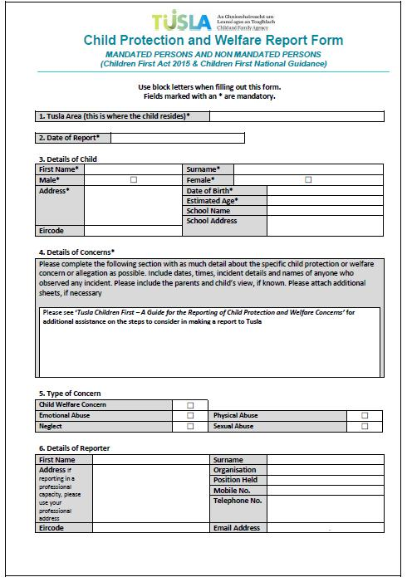

33
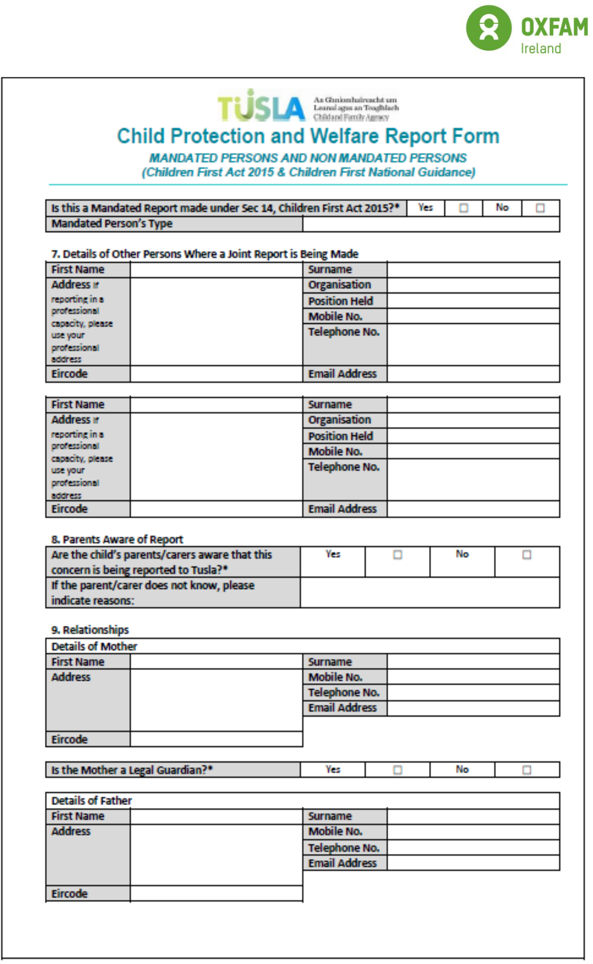

34
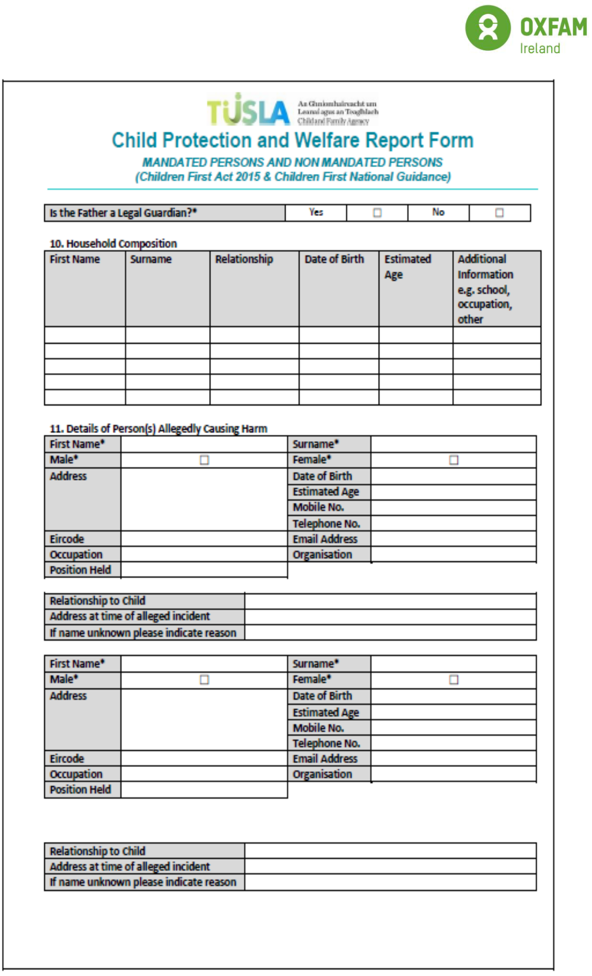

35
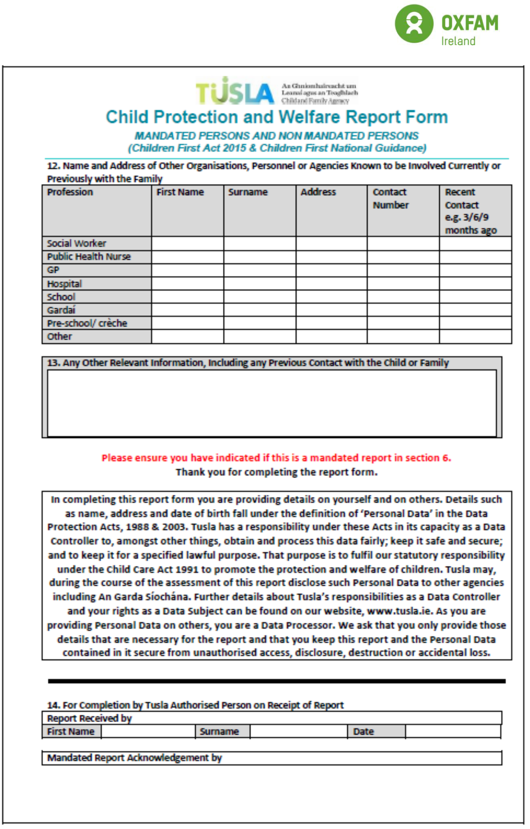

36
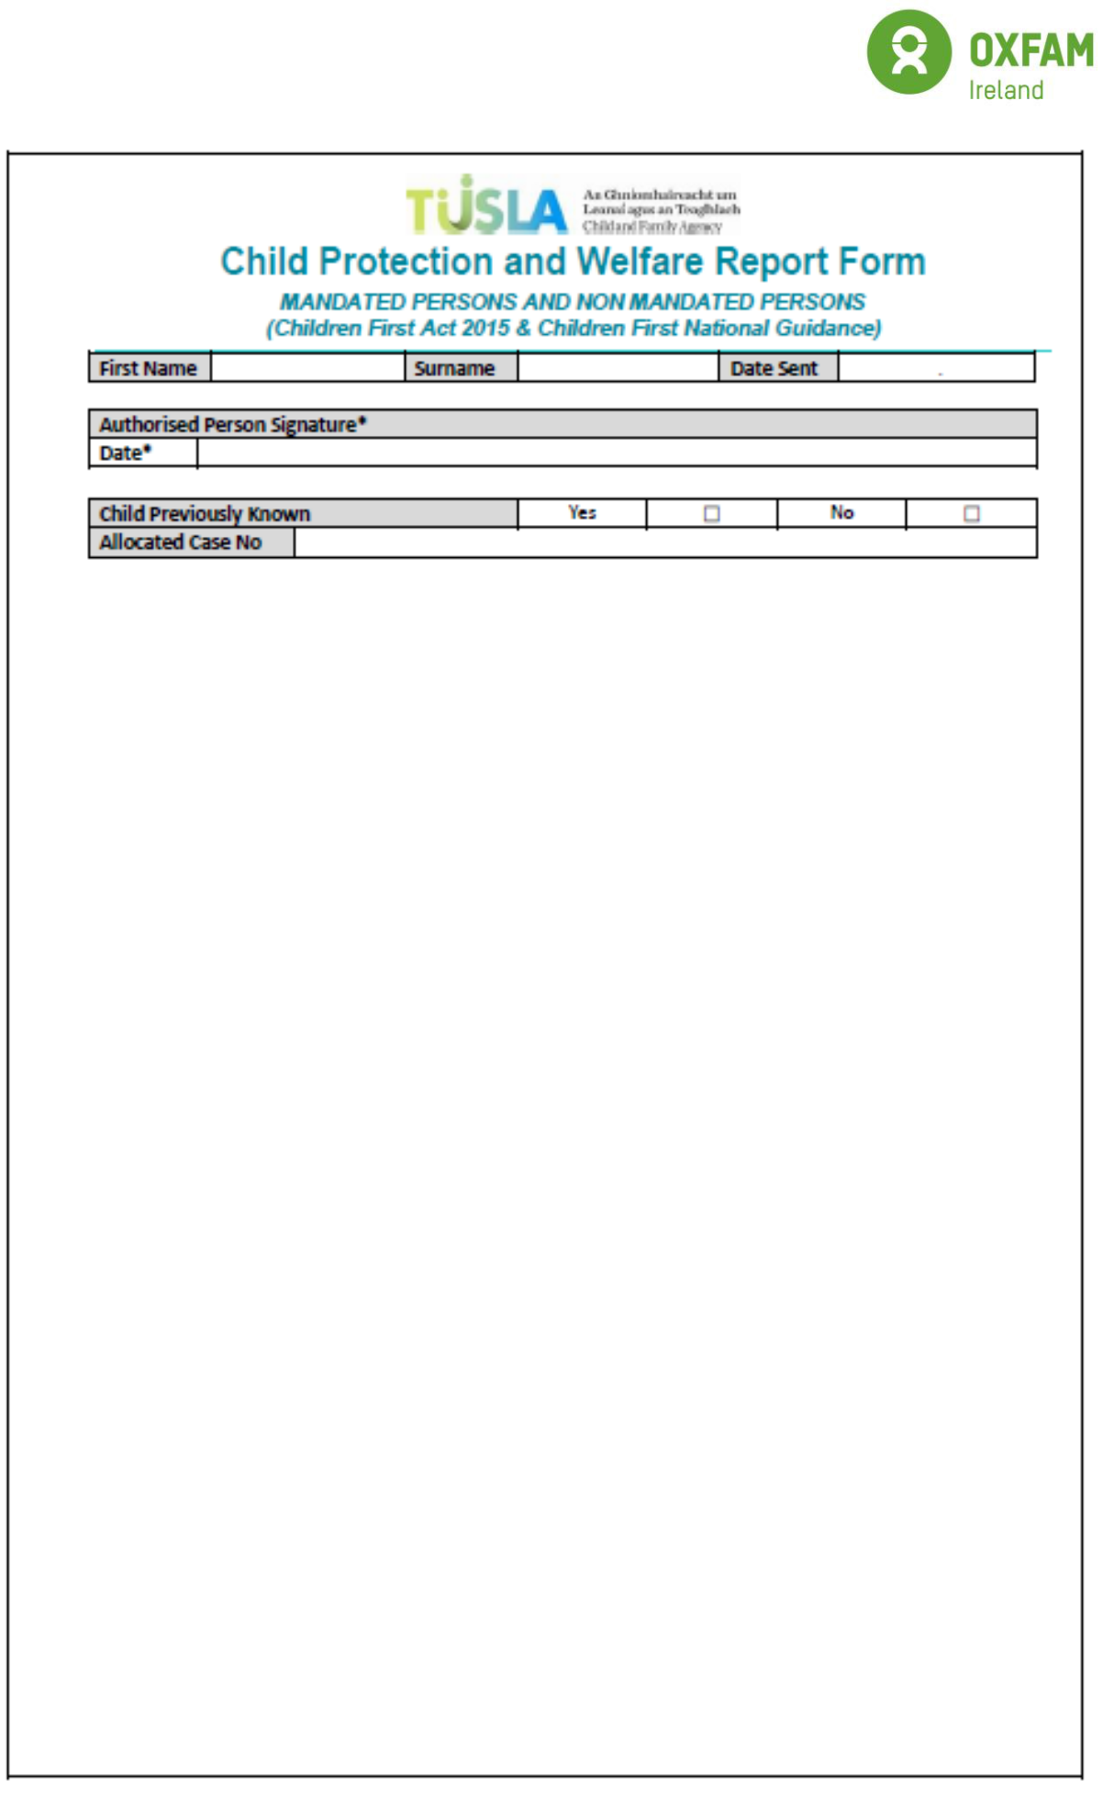

37

Safeguarding Policy Appendix 4
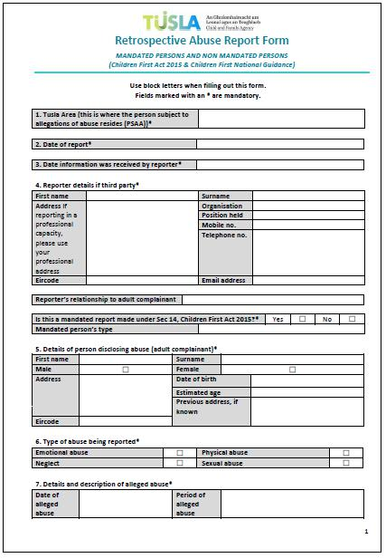

38
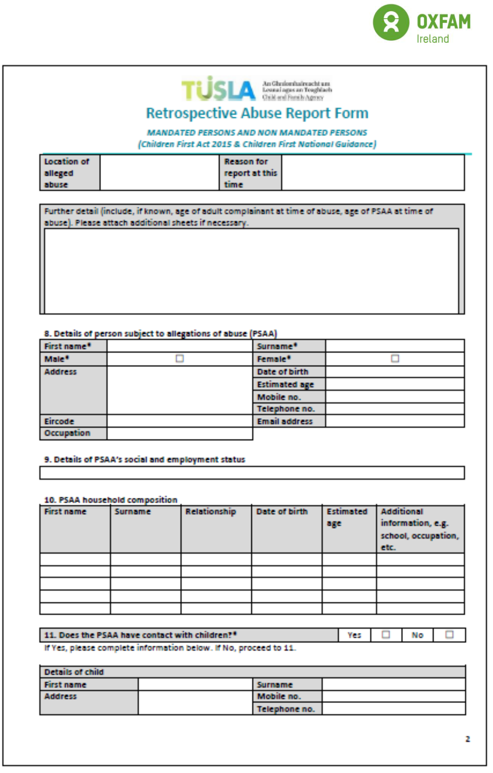

39
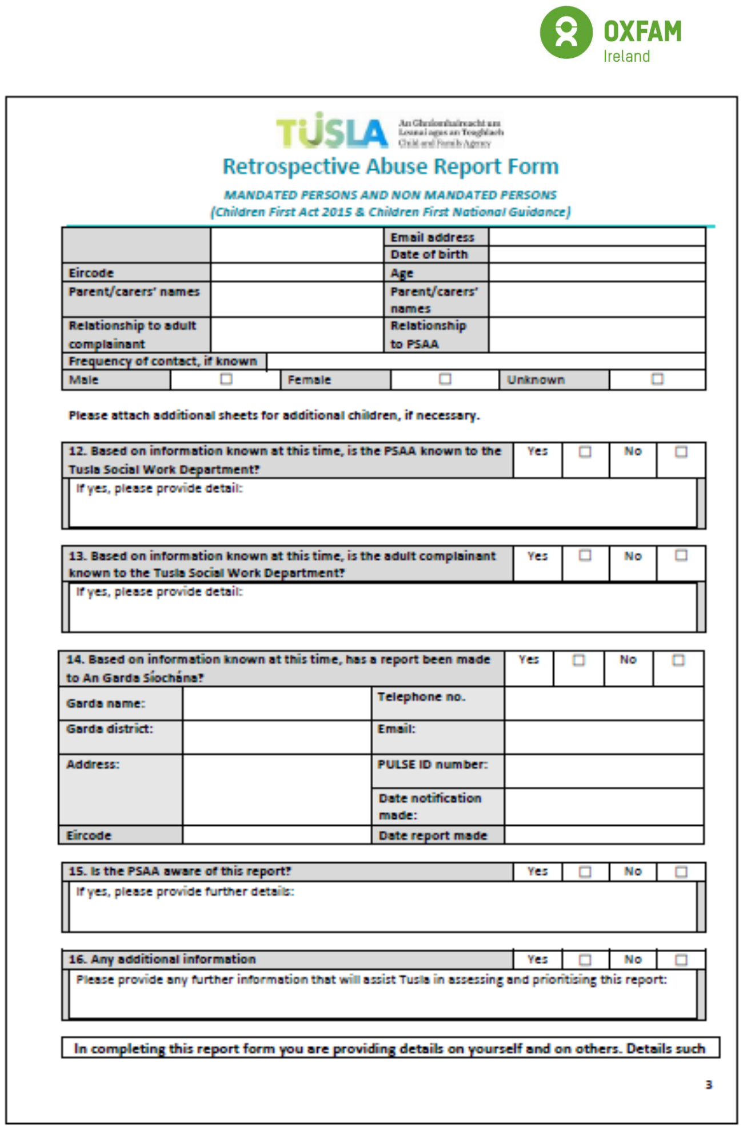

40
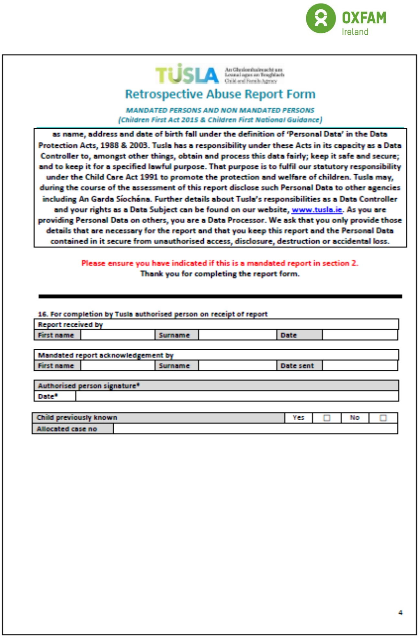

41

Safeguarding Policy Appendix 5 Vulnerable person protection report form

Please answer all relevant questions as fully as you can.

Work location:
Name of vulnerable adult:
Age / Date of birth:
Gender: | □ Female | □ Male
Name of parent(s) /guardian
/carer(s)
(if appropriate known):
Home address (if known):

PLEASE COMPLETE THOSE SECTIONS BELOW THAT ARE RELEVANT
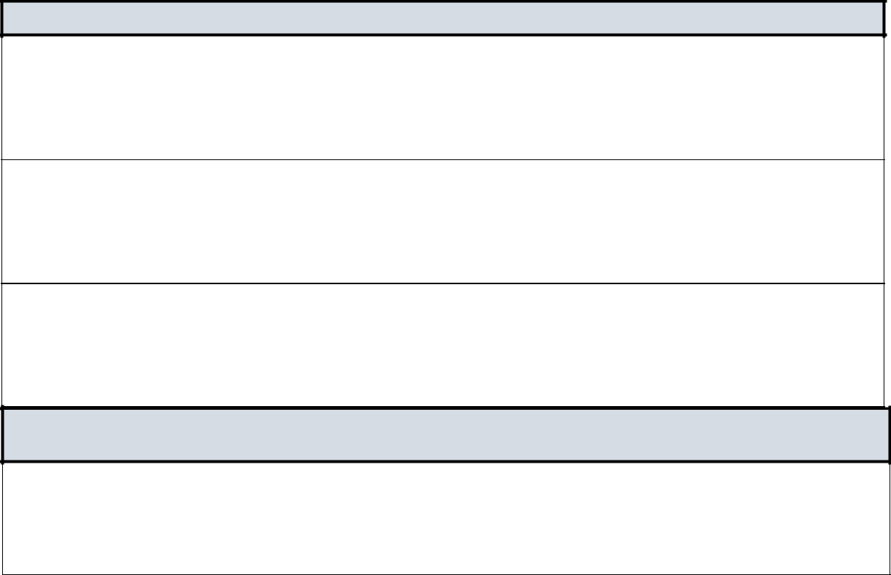

DISCLOSURE BY A VULNERABLE ADULT

When was the disclosure made (dates and times)?

Who did the vulnerable adult make the disclosure to?

What did the vulnerable adult actually say?

CONCERNS EXPRESSED BY ANOTHER PERSON ABOUT A VULNERABLE ADULT

When was the concern expressed (dates and times) and who by (include contact details where possible).

42


Who was the concern expressed to?

Record the concerns expressed and if possible, ask the person who expressed the concerns to confirm that the details as written are correct

43

INDICATORS

Describe any signs or indicators of abuse (with times and dates).


Has there been an allegation that any particular person is the abuser? (If so, please record details and the relationship, if any, to the child/ vulnerable adult below.)

DETAILS OF ANY IMMEDIATE ACTION TAKEN E.G. FIRST AID.


HAS THE VULNERABLE ADULT EXPRESSED ANY RESERVATIONS ABOUT YOU TALKING TO THE DESIGNATED LIAISON PERSON / DEPUTY DESIGNATD LIAISON PERSON ABOUT THE MATTER?

44
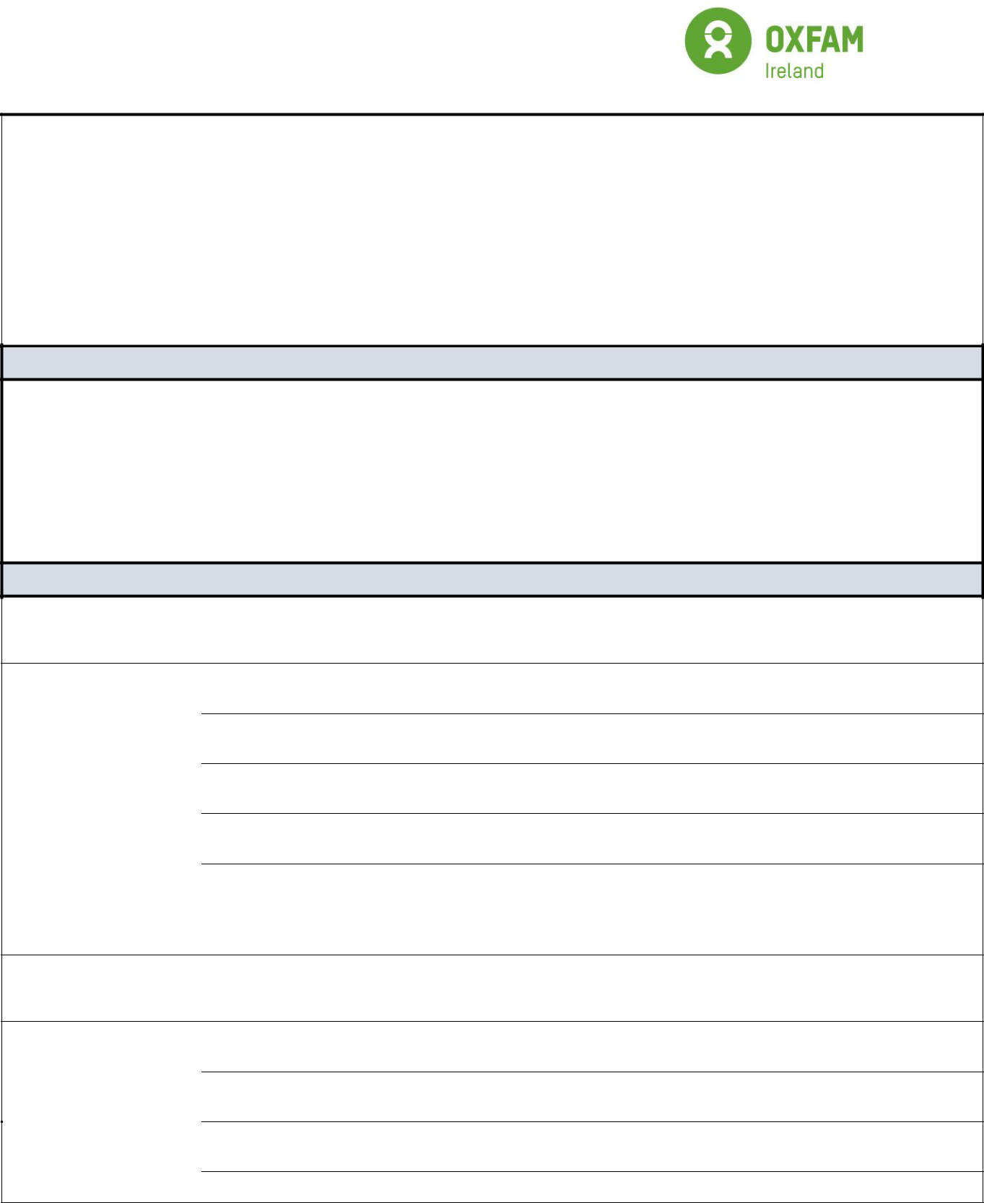

DOES THE VULNERABLE ADULT HAVE ANY PARTICULAR NEEDS E.G. COMMUNICATION NEEDS?

SIGNATURES

To be signed by the person reporting the concern.

Name:

Job/Role title:

Signed:

Date:

Date received and actioned by Designated Liaison Person/Deputy Designated Liaison Person

Name:

Signed:

Date:

45

ACTION TAKEN BY DESIGNATED LIAISON PERSON/ DEPUTY DESIGNATD LIAISON PERSON:

Signed:

Date:

OXFAM DESIGNATED LIAISON PERSON / DEPUTY DESIGNATD LIAISON PERSON

DESIGNATED LIAISON PERSON / DEPUTY DESIGNATD LIAISON PERSON Name:
Address:

Direct line:

46

Safeguarding Policy Appendix 6

Chart 1 - Oxfam Ireland CHILD Safeguarding Reporting procedures (ROI)

This chart shows the procedure for reporting concerns about a child.

Staff / volunteer has concerns

Record and report without delay using Child Protection and Welfare Report Form (Appendix 3) or Retrospective Abuse Report form to your Designated Liaison Person (DLP) / Deputy Designated Liaison Person (DDLP)
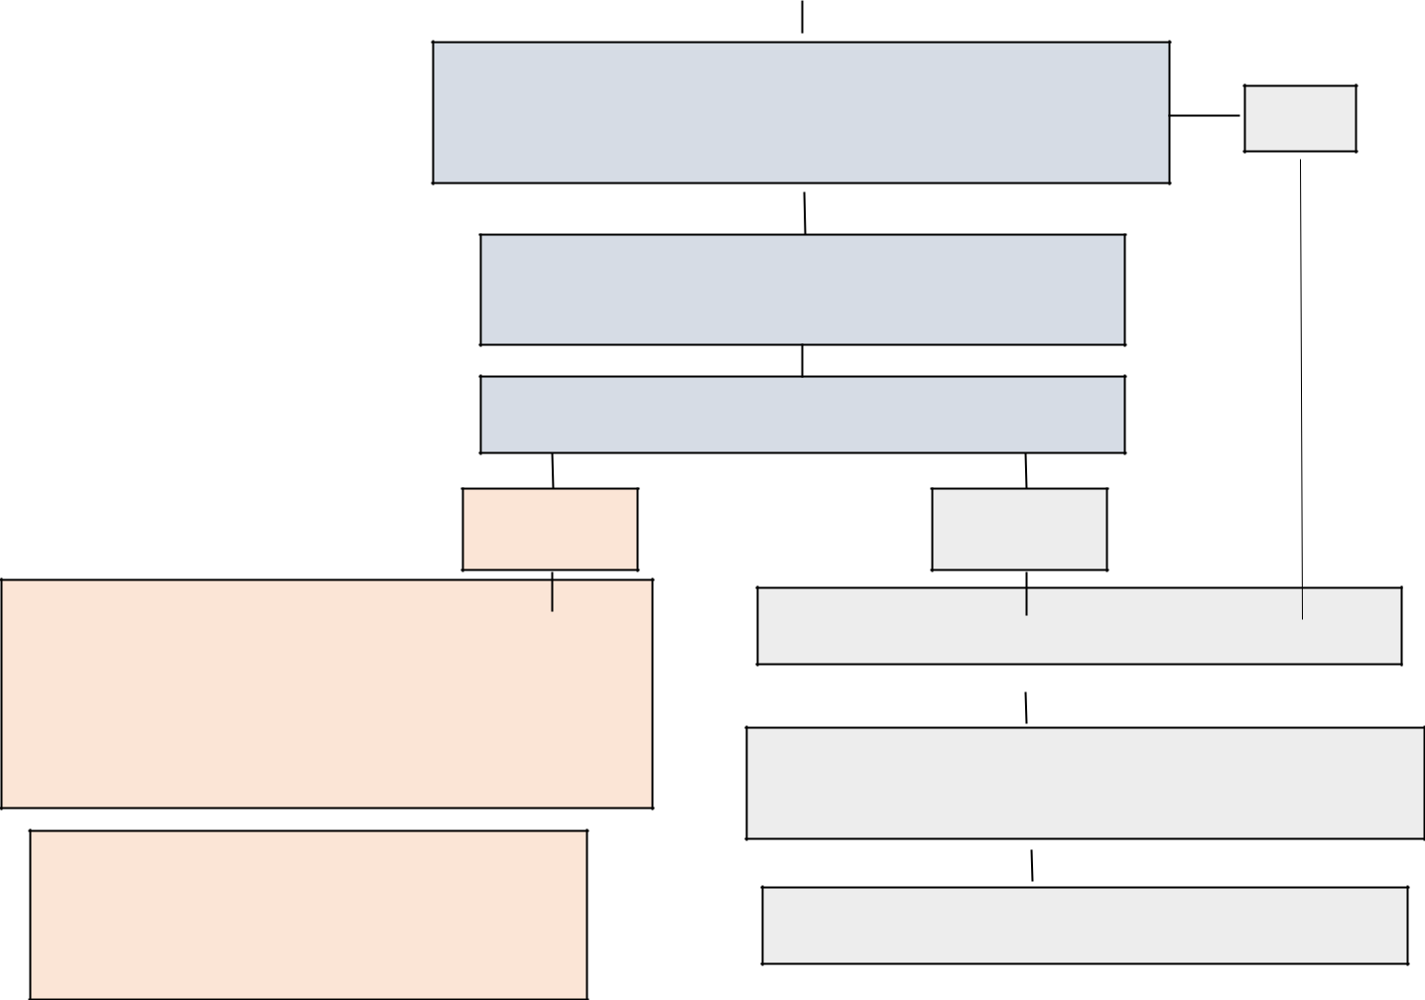

DLP/DDLP ensures immediate safety of the person and
considers whether there are reasonable grounds for concern | No

DLP/DDLP seeks advice from Tusla / An Garda

Síochána (Informal consultation)

Reasonable grounds for concern?

Yes

Refer reported concern to Tusla / An Garda Síochána

using Child Protection and Report Form or

Retrospective Abuse Report form; notify parents /

guardian where it is safe for the child to do so.

Initial screening and assessment of concern reported carried out by Tusla following the Pathway of a child welfare or protection concern reported to Tusla.

No

Keep a record of concerns on file

Take appropriate action regarding other organisational

policies and procedures

Ongoing monitoring of the situation

47

Safeguarding Policy Appendix 7

Chart 2 - Oxfam Ireland Vulnerable Persons Safeguarding Reporting procedures (ROI)

This chart shows the procedure for reporting concerns about a vulnerable adult.

Staff / volunteer has concerns

Record and report without delay using the Vulnerable Adult Protection Form (Appendix 5) to your Designated Liaison Person (DLP) / Deputy Designated Liaison Person (DDLP)

DLP/DDLP ensures immediate safety of the person and
considers whether there are reasonable grounds for concern | No
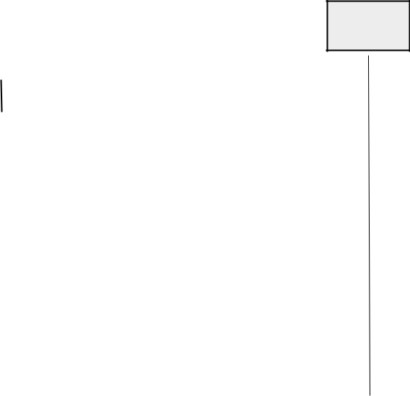

 |  | DLP/DDLP seeks advice An Garda Síochána (Informal
 |  |  |  |  | consultation)
 |  |  | Reasonable grounds for concern?
 |  | Yes |  |  |  |  |  |  | No
 |  |  |  |  |  |  |  | Keep a record of concerns on file
Refer reported concern to An Garda Síochána using
Vulnerable Adult Protection Form (Appendix 5) and where
appropriate notify parents / guardian / carer where it is
 |  |  |  |  |  |  | Take appropriate action regarding other organisational
safe for the vulnerable adult to do so.
 |  |  |  |  |  |  |  |  | policies and procedures
 |  |  |  |  |  |  |  | Ongoing monitoring of the situation

48

Safeguarding Policy Appendix 8

Staff Risk Assessment Form
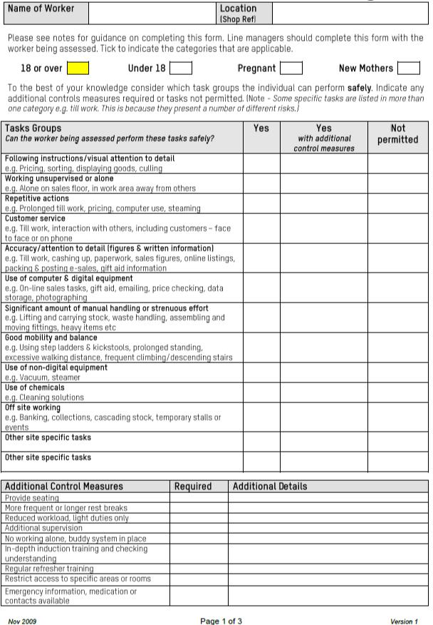

49
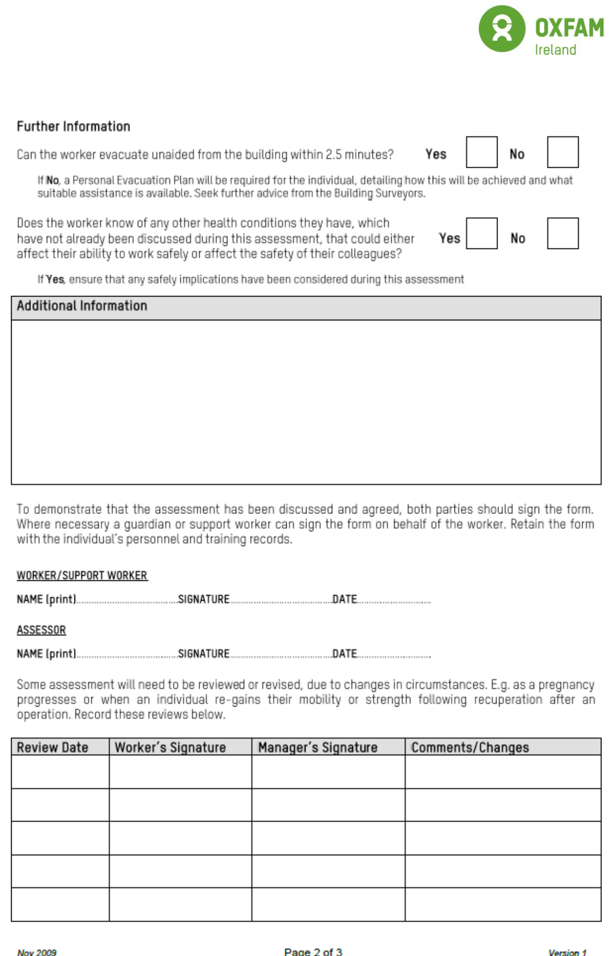

50

Safeguarding Policy Appendix 9

Report of near miss form

SECTION 1 (To be completed by the person to whom the Near Miss is reported)

- DETAILS OF NEAR MISS FORM COMPLETED BY:
NAME: ___________________ POSITION: __________________

DATE FORM COMPLETED: _______________ SIGNATURE: _______________________

DATE OF NEAR MISS: _______________________ TIME OF NEAR MISS: ____________

PRECISE LOCATION OF NEAR MISS: _________________________________________

___________________________________________________________________

Activity at time of Near Miss (X appropriate box)

WORK |  | EVENT
RESULT OF FACE TO FACE |  | Any Other

- EVENT CATEGORY

 |  |  | Identity of Dangerous Occurrence, Person(s),
 | Near Miss Event Category |  | Vehicle(s), Equipment and/or Building(s) Involved
No | (Tick all that apply)
1 | RIDDOR Dangerous Occurrence
2 | Potential injury to person(s)
3 | Potential damage to vehicle(s)
4 | Potential damage to equipment
5 | Potential damage to building(s)

- EVENT DETAILS

Detailed Description of Near Miss event:

51

SECTION 2 (WORKPLACE SUPERVISOR/MANAGER)

Action | Y/N | Date | Comments

Near Miss investigated?

- Written investigation required?

Details of local remedial action(s) taken to prevent recurrence:

________________________________________________________________________________

________________________________________________________________________________

________________________________________________________________________________

________________________________________________________________________________

____________________________________________________________

- Written investigations must be forwarded to the Health and Safety officer within 2 weeks of the date of the Near Miss.

NAME:____________________________ POSITION: _______________________

SIGNATURE: ___________________________ DATE: ______________________

----------------------------------------------------------------------------------

SECTION 3 (To be completed by the Health and Safety officer)

Near Miss recorded on database

Comments:

_______________________________________________________________________________

_______________________________________________________________________________

_______________________________________________________________________________

_______________________________________________________________________________

_______________________________________________________________________________

_______________________________________________________

NAME: ______________________________ POSITION: ___________________

SIGNATURE: ______________________________ DATE: _______________________

52

Safeguarding Policy Appendix 10

Accident and Incident Form (completion by investigating officer) Ensure accident book is completed and is attached to this report.

 |  |  |  |  |  | What are you reporting (Please Tick)
 |  | □ Incident with Injury |  |  |  | □ Incident without Injury |  | □ Dangerous Occurrence
 |  |  |  |  |  | □ Occupational Disease |  | □ Other
 |  | Guidance |  |  |  |  |  | Incident Details
If you require any, further |  |  |  |  | Date of Incident:
support whilst completing this
 |  |  |  |  | Time of Incident:
form then please contact your
 |  |  |  |  | Where did the incident
Supervisor & Health and Safety
 |  |  |  |  | occur?
Officer.
 |  |  |  |  | Was it part of a
 |  |  |  |  | Programme Activity or
 |  |  |  |  | at an Off Site
 |  |  |  |  | address? Please state
 |  |  |  |  | and provide address:
 |  |  |  |  | If Yes, Name of
 |  |  |  |  | Programme
 |  |  |  |  | Was it part of a work
 |  |  |  |  | activity? If so, please
 |  |  |  |  | name activity.
 |  |  |  |  | In which department /
 |  |  |  |  | room – or where on the
 |  |  |  |  | site did this happen:
Did the Injured Person: (Tick all |  |  |  |  |  |  | The Person Involved
that apply)
□ Become unconscious |  |  |  |  | Type of Person
□ Need resuscitation |  |  |  |  | Involved:
□ Attend hospital
 |  |  |  |  | Full Name:
□ Referred to GP
 |  |  |  |  | Their Address:
□ Ambulance called
□ First aid given
□ Removed from activity
 |  |  |  |  | Contact Number:
□ | Sent home
□ |  |  |  |  | Age / DOB (or tick if
□ Return to activity |  |  |  |  | over 18)
 |  |  |  |  |  | 53

 | □ None of above/other (if |  |  |  |  |  |  | About the Injury
 | other please specify) |  | Injury Description
 |  |  | Injured parts of body:
 |  |  | Any known medical
 |  |  | conditions:
 |  |  | Activity Involved at
 |  |  | time of Incident:
 |  |  | Number of people
 |  |  | involved:
 |  |  | If yes, where was
 | Was medical treatment |  | treatment provided: •
 | provided? • Yes • No • |  | on site • Urgent Care
 | Refused |  | • Emergency Room •
 |  |  | Other
 | RIDDOR: Please see Guidance
 | for further details |  | □ Over 3 Day Injury
 |  |  |  |  |  | Type of Incident
 | □ Burns / Scalds |  |  | □ Not following |  |  |  | □ Fall from height
 | □ Challenging behaviour |  |  | instructions |  |  |  | □ Hit by fixed, moving or falling object
 | □Equipment failure / damage |  |  | □ Personal safety |  |  |  | □ Exposure to harmful substances
 | □Illegal drugs / alcohol |  |  | threat |  |  |  | □ Exposure to fire / explosion
 | □ Inappropriate sexual behaviour |  |  | □ Removed from |  |  |  | □ Arrest by police
 | □ Leaving activity without |  |  | activity |  |  |  | □ Other (please specify below)
 | permission |  |  | □ self-harm / |  |  |  | ____________________________________
 | □ Manual handling injury |  |  | overdose
 |  |  |  | □ Slip, trip or fall
 |  |  |  | on same level
 |  |  |  | □ Theft
 |  |  |  | □ Vehicle / driving
 |  |  |  | □ Violent
 |  |  |  | behaviour
 | Full Description of Incident

54


Immediate Action following Incident

Management Actions Taken

The accident must be recorded in an Accident Book (original copy sent to Head Office immediately) In which Accident Book has it been recorded?

Was this as a result of an assault? YES

Were there any witnesses? YES NO

NO

WITNESS NAME: _______________ POSITION: ______________ CONTACT DETAILS: __________

WITNESS NAME: _______________ POSITION: ______________ CONTACT DETAILS: __________

WITNESS NAME: _______________ POSITION: ______________ CONTACT DETAILS: __________

Your Name:

55

Line Manager:

Date:

(H&S USE ONLY)

WITNESS STATEMENT

STATEMENT OF: ______________________________________

Incident details including location, date, and time of incident-

This statement (consisting of ____ pages each signed by myself) is true to the best of my knowledge and

belief.

SIGNED: _______________________________________________

DATE: _________________________________________________

DETAILS:

56

I have read the above statement and I have been able to correct, alter and add anything I wish.

SIGNED: _________________DATE: ____________________

SIGNATURE WITNESSED BY _______________DATE: ___________________

57

Safeguarding Policy Appendix 11

Bullying incident form

 | Name | Gender | Ethnicity | Year
Complainant(s) |  | M / F
Alleged child(s) who has been |  | M / F
bullied (if different from above)
Alleged child(s) who has |  | M / F
displayed bullying behaviour
Date of incident:
Location of incident e.g. corridor, hall, meeting room

Type of incident:

- Physical bullying (includes jostling, physical intimidation, interfering with personal property, punching / kicking, any other physical contact which may include use of weapons)

- Verbal bullying (includes name calling, insults, jokes, threats, spreading rumours)

- Indirect bullying (includes isolation, refusal to work with / talk to / play with / help others)

Theme (if applicable):

- Cyber (through technology such as mobile phones and internet

- Disability (related to perceived or actual disability)

- Homophobic (related to perceived or actual sexual orientation)

- Racist (related to race, ethnic, national origin, colour & nationality)

- Sectarian (related to religious belief and/or political opinion)

Details of incident:

58
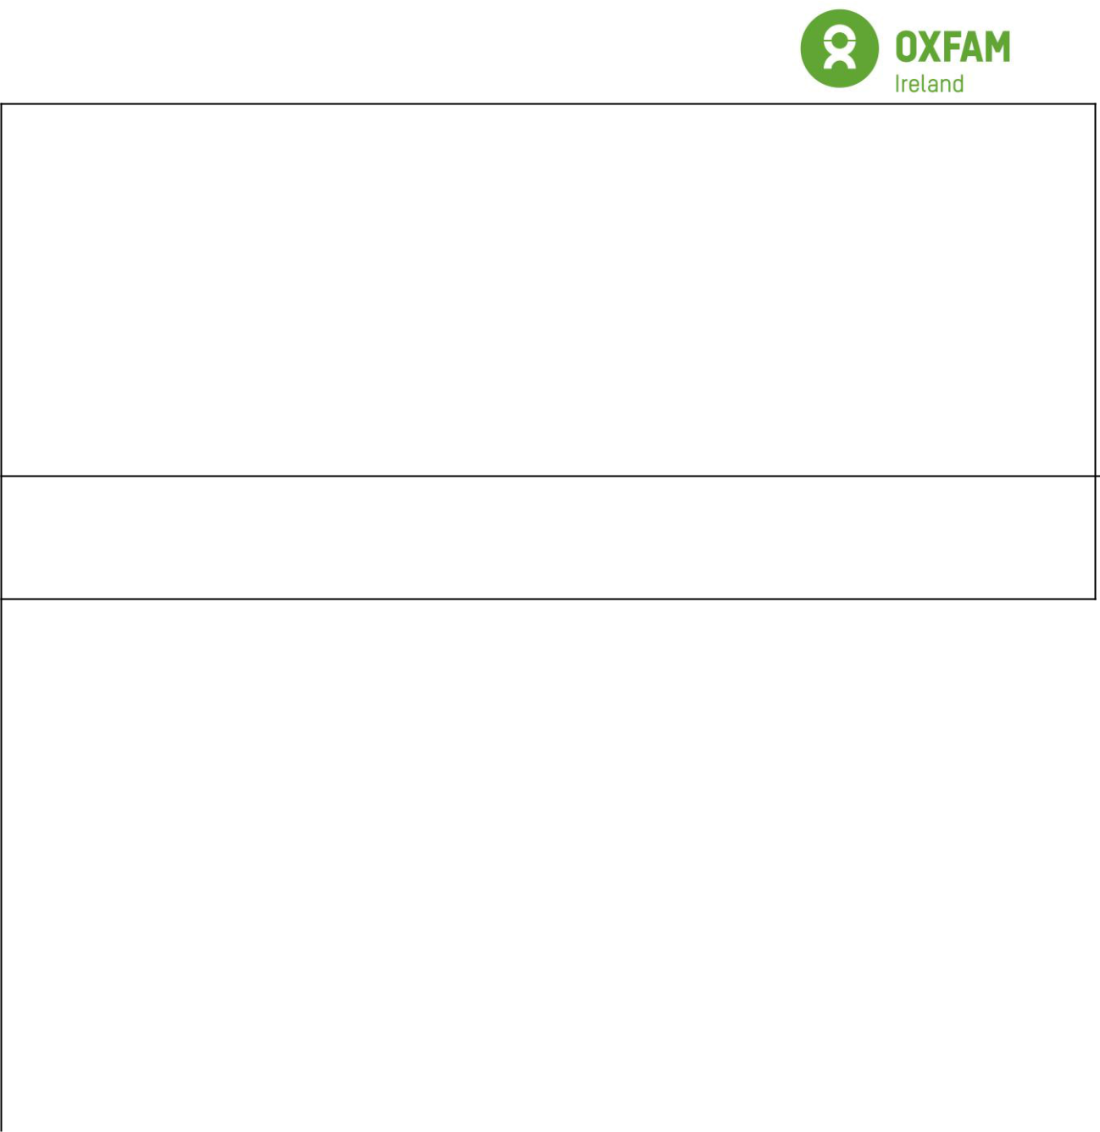

Name of action / support for child(s) who has been bullied: (please tick all that apply)

- Discussion of the incident with peers

- Defined ongoing support/monitoring from staff

- Parents involvement (please specify) ________________________________

- Counselling

- Referral to other agencies (please specify) ________________________________

□ Other (please specify) _________

Name of action / support for child(s) who has been displaying bullying behaviour: (please tick all that apply)

- Discussion of the incident with peers

- Defined ongoing support / monitoring from staff

- Parents involvement (please specify)

- Counselling

- Referral to other agencies (please specify)

- Fixed exclusion

- Permanent exclusion

□ Other (please specify) ________

Outcome (level of satisfaction)

Good = 1 Satisfactory = 2 Poor = 3 Unresolved = 4

Young person who has been bullied

Parents of above young person

Young person who has displayed bullying behaviour Parents of above young person

This record is now:

- Filed

- Passed to staff member responsible for safeguarding

- Passed to external agency – please state

59


Name and designation of the staff member completing this form: | Date:
Signed:

60

